**IPL tournament business model**

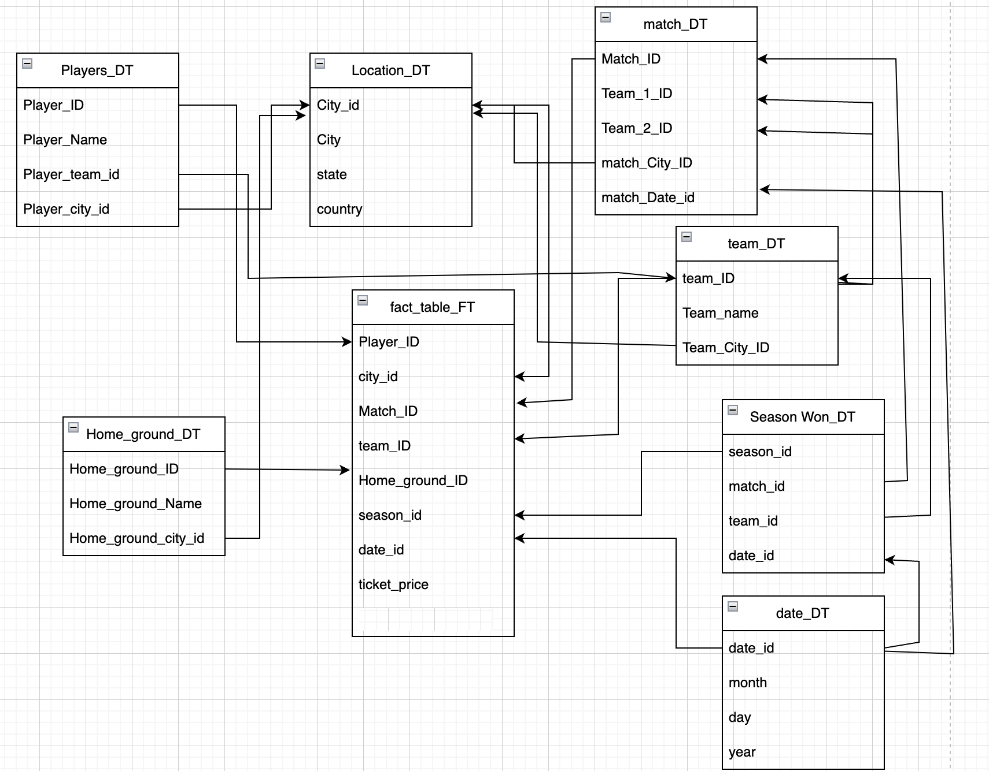

1. **How many teams were playing the IPL match and what are their team name?**

Select count(*) from team_dt

Select team_name from team_dt

1. **Which city most IPL payers belong to?**

Select count(player_name) as number_of_players , l.city

from players_dt p left join location_dt l on p.player_city_id = l.city_id

group by city order by number_of_players desc limit 1;

1. **How many tickets sold, when a team played in home ground?**

Select count(f.ticket_price) as no_tickets_sold ,t.team_name

from team_dt t join fact_table_ft f on t.team_id = f.team_id

Join home_ground_dt h on h. home_ground_id = f. home_ground_dt

Group by team_name order by no_tickets_sold desc;

1. **Which team has won the most seasons and which city they represent?**

Select count(t.team_id) as no.times_team_won,l.city,t.team_name

from season_won_dt s join team_dt t on t.team_id = s.team_id

Join location_dt l on t.team_city_id = l.city_id

Group by l.city,t.team_name order by no.times_team_won desc;

1. **How many tickets sold for each match?**

Select count(f.ticket_price) as no_tickets_sold,m.match_id

from match_dt m join fact_table_ft f on m.match_id = f.match_id

Group by m.match_id order by no_tickets_sold desc;

1. **Where did the 5th match happen and what are the teams participated in the match**

Select l.city, t1.team_name,t2.team_name

from match_dt m join team_dt t1 on t1.team_id = m.team_1_id

join team_dt t2 on t2.team_id = m.team_2_id

join location_dt l on l.city_id = m.match_city_id

where match_id =5

1. **What is the average numbers of tickets sold in all the match**

Select avg (total_count) from

(Select count(f.ticket_price) as total_count from match_dt m join fact_table_ft f on f.match_id = m.match_id group by m.match_id) as p ;

**Food delivery app data warehouse model**

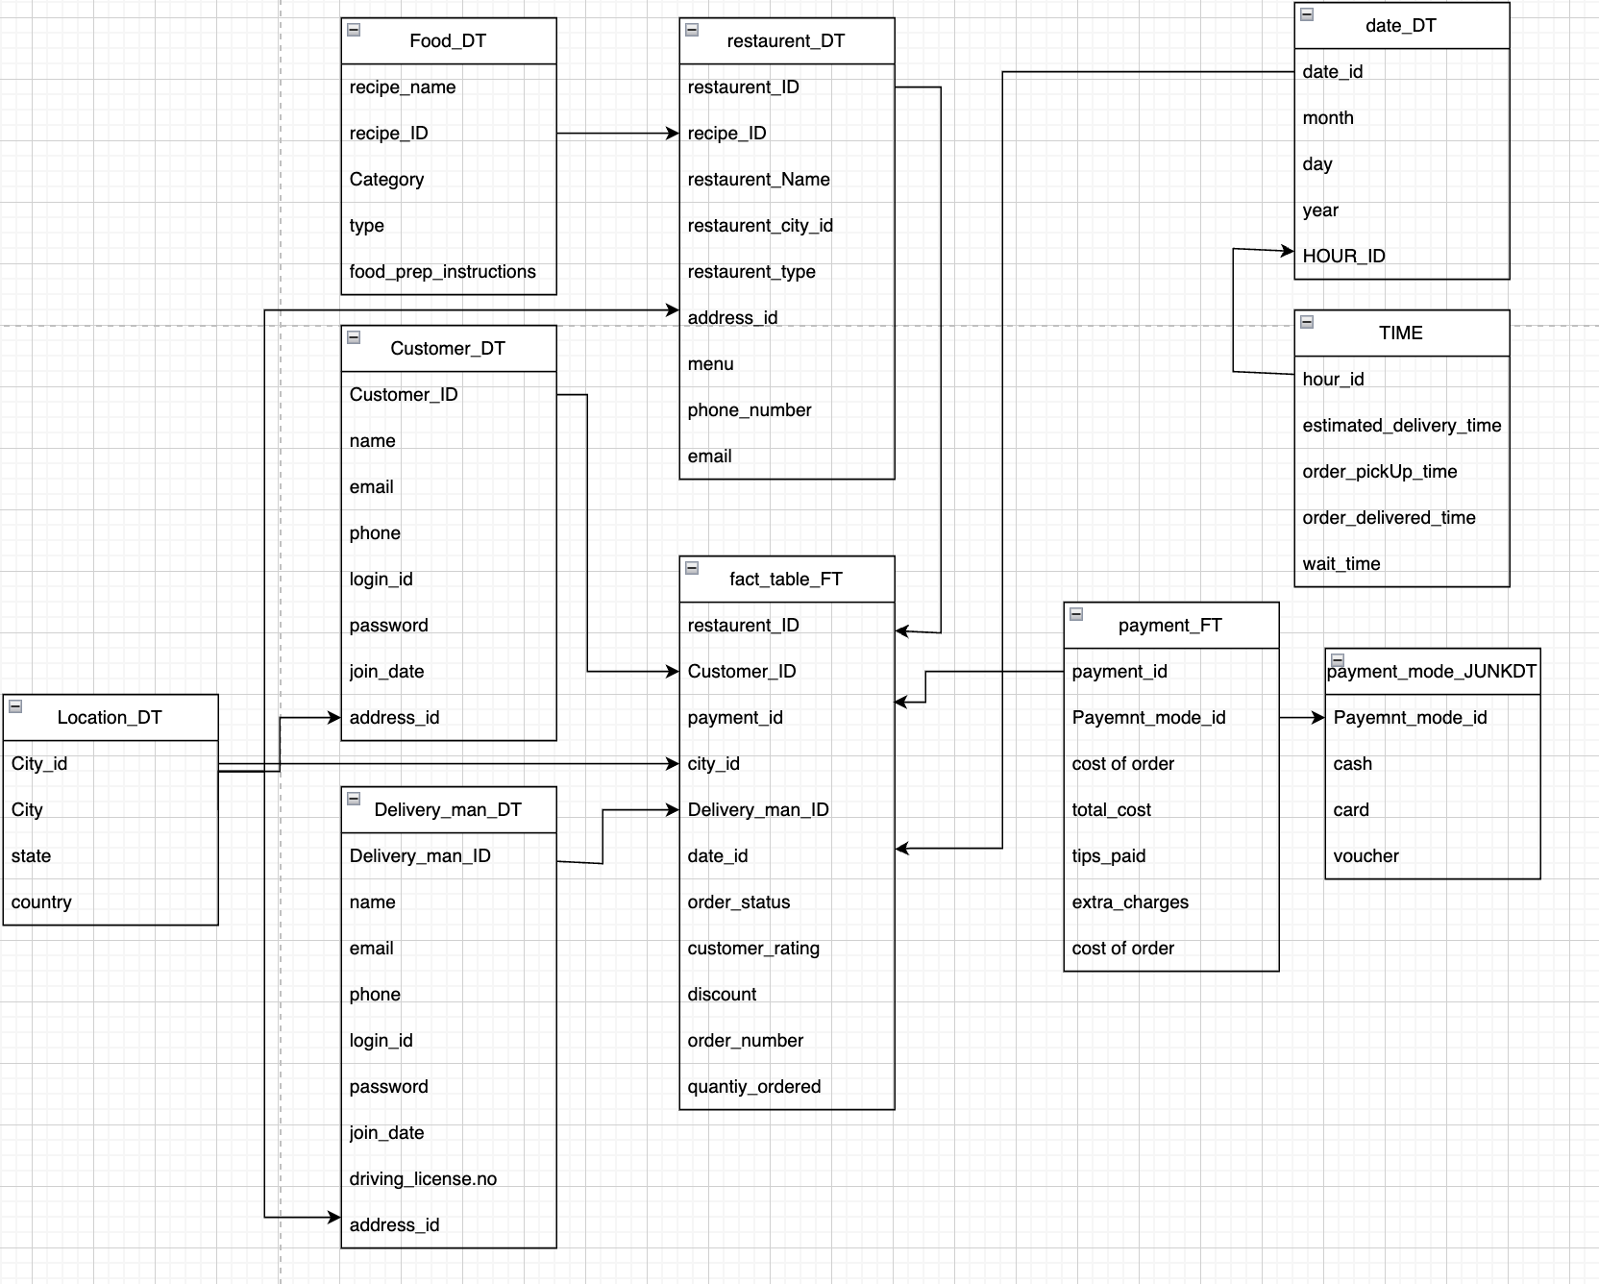

1. **Find how many orders each customer ordered**

SELECT count(f.Order_number) as order_Count,c.Name

FROM Customer_dt c join fact_table_ft f on c.Customer_ID = f.CustomerID

group by C.Name order by order_Count desc;

1. **Which restaurant has the highest orders**

Select count(f. Order_number) as order_count

From restaurant_dt r join fact_table_ft f on r.restauresnt_ID = f. restauresnt_ID

Group by restaurant_name order my order_count desc limit 1;

**3)Which recipe has the most customers ordered**

Select food.recipe_name, count(f.order_number) as number_of_count from fact_table_ft f Join restaurant_dt r on f. restauresnt_ID = r. restauresnt_ID

Join food_dt food on food. restauresnt_ID = r. restauresnt_ID

Group by food.recipe_name order by number_of_count desc;

**4)How many customers paid with vouchers and cards**

**With cte as (**SELECT count(c.name) as number_of_customers, j.cash

FROM Customer_dt c join fact_table_ft f on c.Customer_ID = f.CustomerID

Join payment_ft p on f.payment_id = p.payment_id

Join payment_modejunkdt j on j.payment_mode_id = p. payment_mode_id

Where j.cash =1

group by j.cash order by number_of_customers),

cte1 as (

SELECT count(c.name) as number_of_customers, j.voucher

FROM Customer_dt c join fact_table_ft f on c.Customer_ID = f.CustomerID

Join payment_ft p on f.payment_id = p.payment_id

Join payment_modejunkdt j on j.payment_mode_id = p. payment_mode_id

Where j.voucher =1

group by j.voucher order by number_of_customers)

select number_of_customers, j.cash as cash from cte

union all

select number_of_customers, j.voucher as voucher from cte1;

1. **Which delivery person has the highest rating**

Select max(f.delivery_rating) as highest_Rating ,d.name

from delivery_man_dt d join fact_table_ft f on f.delivery_man_id = d. delivery_man_id

Group by d.name order by highest_Rating desc limit 1;

1. **Which delivery person has the highest tips**

Select sum(p.tips_paid) as highest_tips ,d.name

from delivery_man_dt d join fact_table_ft f on f.delivery_man_id = d. delivery_man_id

join payment_ft p on p.payment_id = f.payment_id

Group by d.name order by highest_tips desc limit 1;

1. **Which city has the highest orders**

Select count(f.order_number) as number_of_orders, l.city

from location_dt l join fact_table_ft f on f.city_id=l.city_id

Group by l.city order by number_of_orders

**Restaurant table booking app Datawarehouse design model**

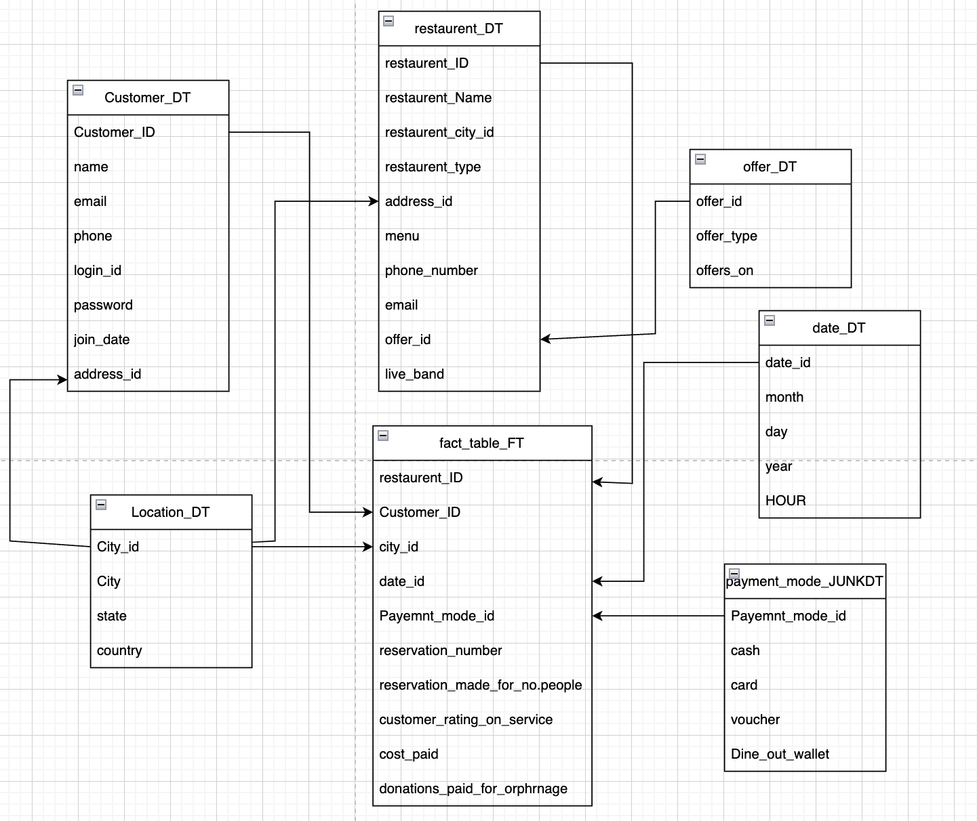

1. **find which city has the highest customers ?**

select count(c.name) as no.of_customer_count,l.city

from customer_dt c join location_dt l on l.city_id= c.address_id

group by l.city order by no.of_customer_count desc limit 1;

**2)find the Customer who paid highest bill ?**

Select sum(f.cost_paid) as highest_cost_paid, c.name

from customer_dt c join fact_table_ft f on f.customer_id=c.customer_id

group by c.name order by highest_cost_paid desc limit 1;

**3)find the customer who reserved table for more than 10 people**

Select c.name

from customer_dt c join fact_table_ft f on f.customer_id=c.customer_id

where f.reservation_made_for_no.of_people >=10;

**4)Find the customer who paid from dine out wallet**

Select c.name

from customer_dt c join fact_table_ft f on f.customer_id=c.customer_id

join payment_mode_junkdt p on p.payment_mode_id= f.payment_mode_id

where p.dine_out_wallet = 1;

**5) find out the number of customers made reservations of table during the month January 2022**

select count(f.reservation_number) as number_of_reservations_in_january

from fact_table_ft f join date_dt d on d.date_id = f.date_id

where d.month = 01 and d.year = 2022;

**6)find out customers who paid extra amount for donation**

Select c.name

from customer_dt c join fact_table_ft f on f.customer_id=c.customer_id

where f.donation_paid_for_orphanage = 1;

**7) what is the average cost paid for 2 people?**

Select avg(cost_paid) as average_cost from fact_table_ft where reservation_made_for_no.people = 2

**8)find all the restaurants who offer live bands and number of the customers went to live band**

Select count(c.name) as number_of_customers ,r.restaurent_name

from customers_dt c join fact_table_ft f on c.customer_id = f.customer_id

Join restaurant_dt on r.restaurent_id = f.restaurent_id

Where r.live_band=’yes’

Group by r.restaurent_name order by number_of_customers desc;

**9)find number of restaurents whose type is “bar and restaurent”**

Select restaurant_name from restaurant_dt where type = ‘bar and restaurent’

**Covid vaccine Application Datawarehouse model**

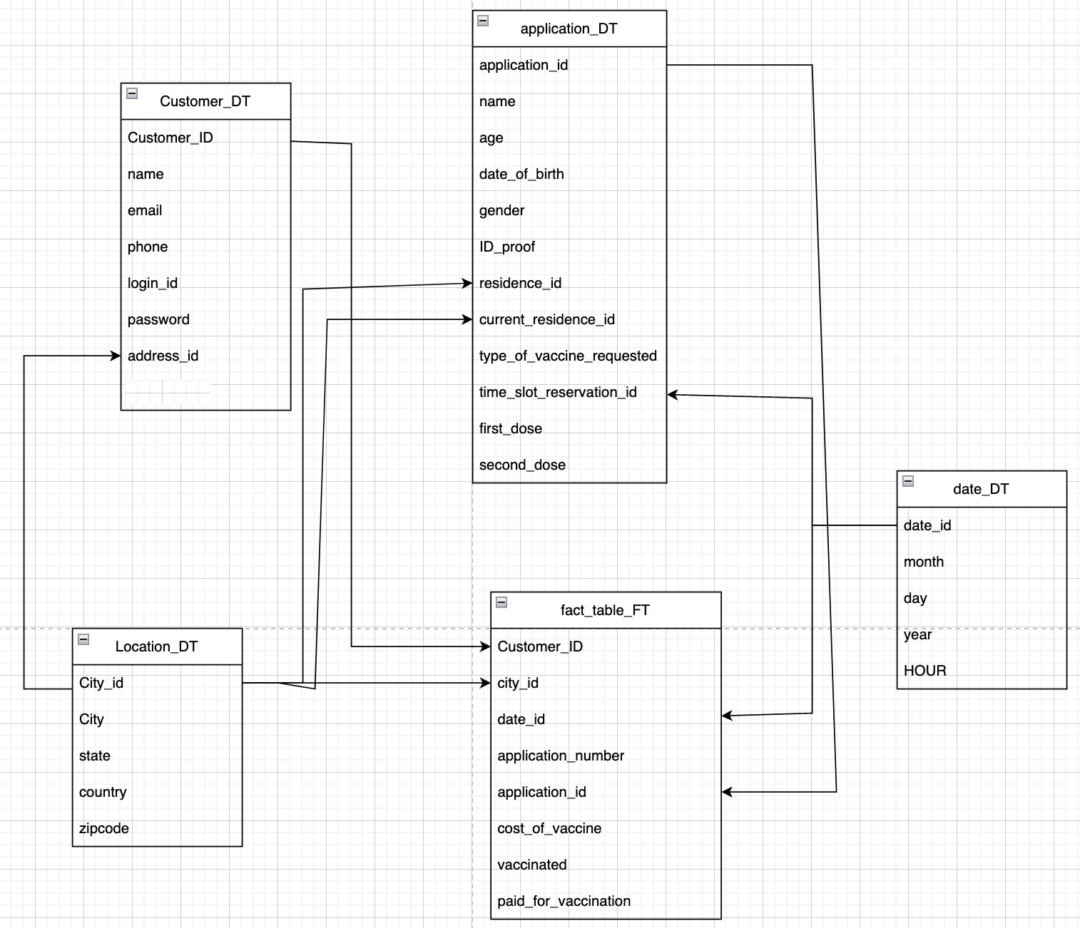

**1)find all the customers who booked appointment in January 2022**

Select c.name from customers_dt c join fact_table_ft f on f.customer_id=c.customer_id

Join application_dt a on a.application_id = f.application_id

Join date_dt d on d.date_id=a.time_slot_reservation_id

Where d.month = 01 and d.year = 2022

**2)find how many customers applied for first dose**

Select count(name) as no.of_customers from customers_dt c join fact_table_ft f on f.customer_id=c.customer_id

Join application_dt a on a.application_id = f.application_id

Where a.first_dose = ‘No’

**3)how many people vaccinated in January**

Select count(c.name) as no.of_vaccinated_people from customers_dt c join fact_table_ft f on f.customer_id=c.customer_id

Join date_dt d on d.date_id=f.date_id

Where d.month = 01 and d.year = 2022 and f.vaccinated = 1

**4)find how many customers had first and second dose and applied for third dose**

Select count(name) as no.of_customers from customers_dt c join fact_table_ft f on f.customer_id=c.customer_id

Join application_dt a on a.application_id = f.application_id

Where a.first_dose = ‘yes’ and a.second_dose=’yes’;

**5)find all the customers who used paid vaccine**

Select c.name as customer_name from customers_dt c join fact_table_ft f on f.customer_id=c.customer_id

Where f.paid_for_vaccination=1

**6) what is the total amount received upon paid vaccine**

Select sum(cost_of_vaccine ) as total_amount from fact_table_ft

Where paid_for_vaccine=1;

**7)find how many application request received on jan 22**

Select count(f.application_number) as applications_Request from fact_table_ft f join date_dt d on d.date_dt = f.date_dt

Where d.month = 02 and day = 22;

**cab ride service Datawarehouse**

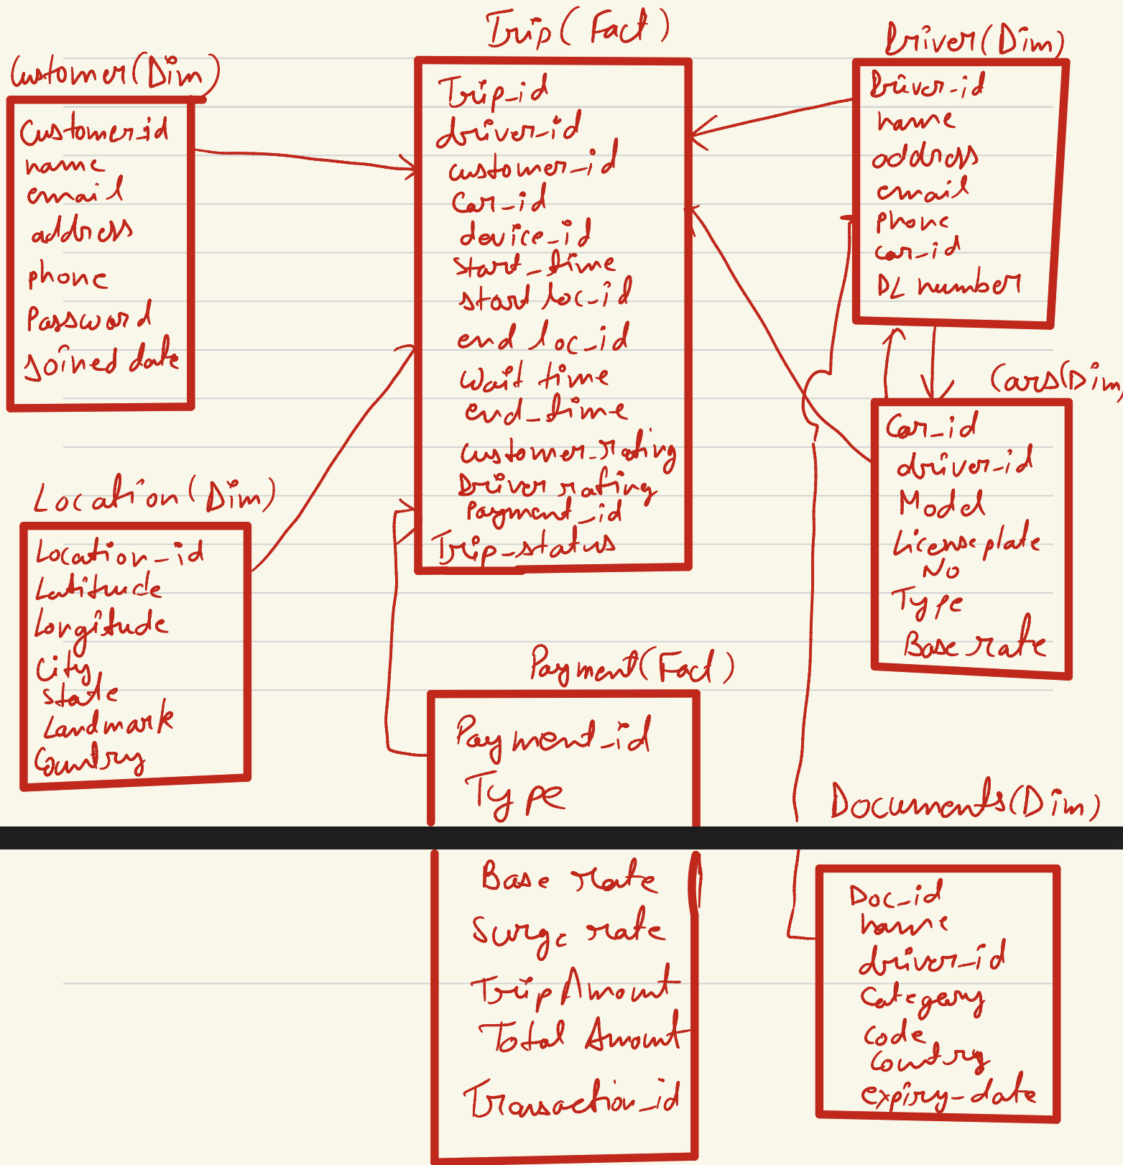

**Note: there is already a design related to this so I’m not creating the new one but I write the business queries**

1. **what Is the total trips taken by each customer**

select c.name, count(p.transaction_id) as number_of_count

from customer c join trip t on t.customer_id = c.customer_id

join payment p on p.payment_id =t.payment_id

group by c.name, order by number_of_count desc;

1. **what is the average amount of total amount that trips taken to ‘hyderabad’**

select avg(p.total_amount) as average_amount

from payment p join trips t on p.payment_id = t.payment_id

join location l on l.location_id = t.location_id

where l.city = ‘Hyderabad’;

1. **what is the destination name that most customers took**

select l.city as destination_name, count(p.transaction_id) as number_of_trips

from payment p join trips t on p.payment_id = t.payment_id

join location l on l.location_id = t.location_id

group by l.city order by number_of_trips desc limit 1;

1. **which driver has the highest rating**

select count(t.customer_rating) as highest_rating,d.name

from driver d join trip t on d.driver_Id = t.driver_id group by d.name order by highest_rating desc limit 1